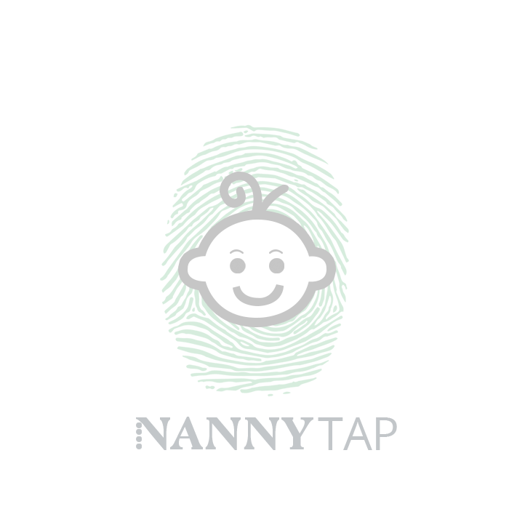

Frequently Asked Questions.

What information do Nannytap need to know about my child in advance?
All children must have a completed information form so that we know as much as possible about your child’s. e.g./ Allergies, any medical illnesses, SEN. This is to ensure we deliver the right care and have consent to act on your behalf in an emergency situation.

Who can pick up my child?
Before booking date or on arrival, Nannytap require your child’s information form and details to be filled in. The person who drops off your child at the creche, child must be the person who collects them. Your child will need to be signed in and out of the creche. In the event the parent cannot pick up, then we will run a password system, this password will be put down on the form in advance and it will be required on pick up.

How do I know my child(ren) will be in safe hands?
Nannytap child carers are working professionals, fully vetted, which means they all have:
- Qualifications
- Child Care Experience
- Interviewed
- Current up to date DBS/ Check (police check)
- will hold a First Aid certificate
- safeguarding trained
- arrive uniform provided, ID badged

How many staff will look after my child/ren?
Nannytap works to the Ofsted ratio requirements. I take in consideration ages and children’s specific needs. Children under 6 months May require 1:1 Nanny (to be discussed on consultation)

Do child carers or pop up crèches need to be registered with Ofsted?
Under current legislation the childcare I provide is exempt from Ofsted registration. This is because the child care happens with parents close by or on same premises. Nannytap Crèches' are in line with Ofsted standards and comply with these at all times. Each Nanny is a trained professional working or studying in the child care sector, for eg/ Teacher, Teaching Assistant, Early years practitioner etc holding qualifications, training & a DBS.

What happens in the event of a fire?
We will evacuate all of the children in accordance with the venue's evacuation procedures. Parents may escort us to the evacuation point or meet us there, if close by. We will either re-enter the building or sign children out from the evacuation point and handed back to the parents. if the building is deemed unsafe to return.

Do you carry out risk assessments?
Nannytap Crèches carries out a full risk assessment of the areas to be used for children and agrees with the venue if changes need to be made. If a venue requires risk assessment this is completed in advance. All children will receive a wrist band or sticker badge with I’m with the Nannytap creche once they arrive at creche

What insurance does Nannytap hold?
All child carers hold individual nanny liability insurance, and Nannytap Ltd have public and employers liability insurance

What space is required for a pop up crèche?
We require a suitable room or space (function room/hotel suite) that is safe and secure to entertain children. Whilst we can turn most space into a children's play area here are some considerations and requirements:
The event space needs to:
- Have the ability to be made secure
- Be available for sole use by Nannytap
- Have toilet facilities nearby (1 toilet & hand basin to every 10 children)
- Be 3.7 sq metres of unencumbered space per child
- Have all free standing, unsuitable equipment and furniture removed
- Be available at least 1 hour before/after the event for set up/pack down.

What sort of activities will you do?
Our pop up play creches includes both structured craft activities and free play activities. All toys, games and equipment will be age appropriate.

On the Day Questions

Is there anything I need to bring?
If your child is still in nappies then we ask that you bring plenty to last for the duration, along with baby milk already made up. we do not supply hot food. Any food/ snacks /Packed Lunches will need to be supplied by parents or by the wedding venue.

Do I need to bring any money?
No, while your child is in our care they will not require any money.

If my child gets upset how will I know?
If we cannot settle your child within 20 minutes then we will contact you and keep you informed. We do are upmost to help your child, using are top nanny strategies using toys as distraction. We will keep in contact via text message or in a way you wish, sending any snap shots over to you whilst they play to keep you reassured. (With your permission) if they will not settle you're welcome to come settle them or take the child with you if you so wish.

Can I stay with my child? Yes of course whilst settling in, although I do advise that you leave your child as they often settle more quickly when parents are not present.

